# “Freeze it”?? “Live it”??

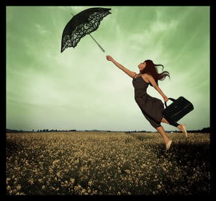-Mahika Bhasin, BVCOE

Garnering memories is a risky pastime. Well, a bone of contention according to today’s scenario. But I stick to it. I rarely take pictures, and I no longer keep a regular diary. This habit has its own grassroots story.

Some years ago, writing in a diary used to be a customary activity. I would return from school and dedicate the expected hour to diligently documenting the day's events, feelings and impressions in my little black leather volume. Moreover, the utopian profiles of people on social networking sites, showcasing their impeccable clicks, aroused the keen interest for photography. Hence, I used to think that pictures blended with words are worth limitless emotions and memories.

Once, I went on a trip and observed that I became obsessed with chronicling every occurrence. Whatever name and place I encountered was readily noted down and captured in my camera. I had many photographs of myself, places, lush green vegetation and scenic beauties of nature. I uploaded all of them on social networking sites and plenty of “likes” swept in. Indeed, acclamation by adoration. As per my mind’s fabrication, I was trying to seek contentment and calmness through them. But, unfortunately, it was missing. Therefore, on the following day, I left my camera and diary and just strolled along the sites.

At that point, I understood that nothing I wrote could ever parallel or replace the few seconds I allowed myself to experience the infallible beauty of my surroundings. All the past days sounded useless and stale. All the sentences I had so tenderly molded and all the pictures I had enthusiastically captured just indicated the dull characterization of those events. By putting my adventure into perspective, I completely forgot to live it. Then, I realized that if I stay too preoccupied behind the camera in the hope of cherishing these memories in the future, my present will simply pass by me. I don’t want to wake up one day with piles of photos to which I am not connected. Maybe, in this way I will forget the precise representations of people and places but at least those experiences will stay inside me and ring a bell.

I don’t live to make memories. I just live and the memories form themselves.

